**Clustering - Financial Documents**

Public companies release financial reports to communicate their financial performance, position, and activities to stakeholders. These reports are rich in data, often structured across multiple tables, each serving a distinct purpose.

From an analytics perspective, clustering these tables into predefined categories helps streamline data extraction, comparison, and analysis, enabling more effective insights.

The primary categories include:

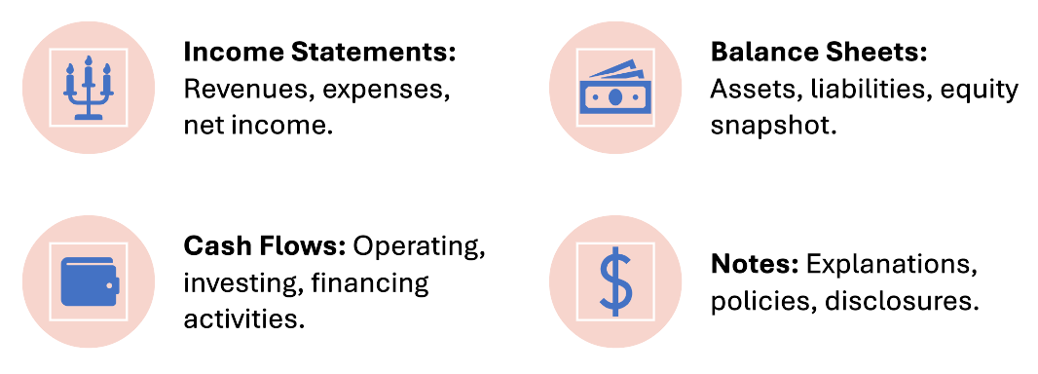

By clustering financial tables into these standardized categories, analytics professionals can efficiently identify patterns, detect anomalies, and generate actionable insights.

**Data:** Financial tables given in html format distributed as below with total files size **2573**

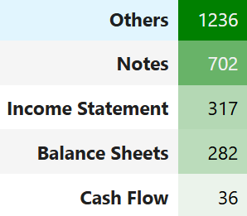

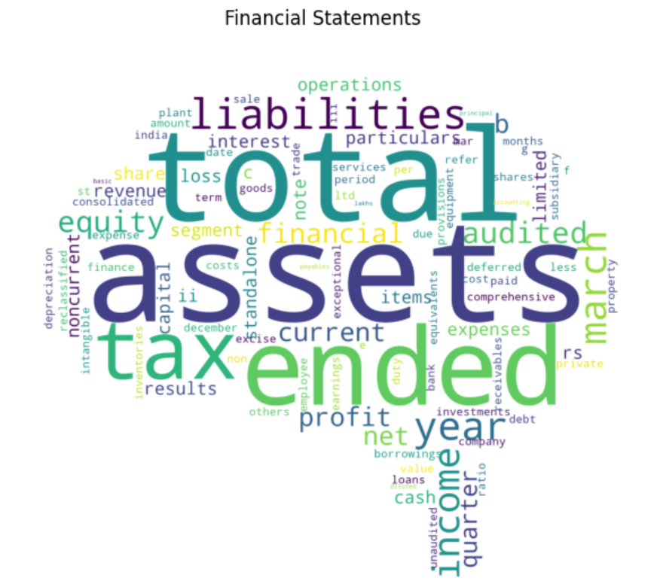

**Financial Table Clustering Workflow**

* **Extract Tables from HTML:** Import financial tables from HTML files and convert them into text strings.
* **Filter Key Metrics:** Retain only relevant financial metric names for analysis.
* **Text Preprocessing:** Clean and standardize text data using NLTK.
* **TF-IDF Matrix Creation:** Build a TF-IDF matrix to represent textual data numerically.
* **Dimensionality Reduction with NMF:** Decompose the sparse TF-IDF matrix using NMF to identify key features from each component.
* **Clustering with K-Means:** Apply the K-Means algorithm (K=5) to classify tables into five predefined categories.
* **Cluster Validation:** Evaluate clustering performance using the Elbow Method and Average Silhouette Width to determine optimal cluster numbers.

For above financial documents it was observed that Average Silhouette Width was optimal with 5 clusters.

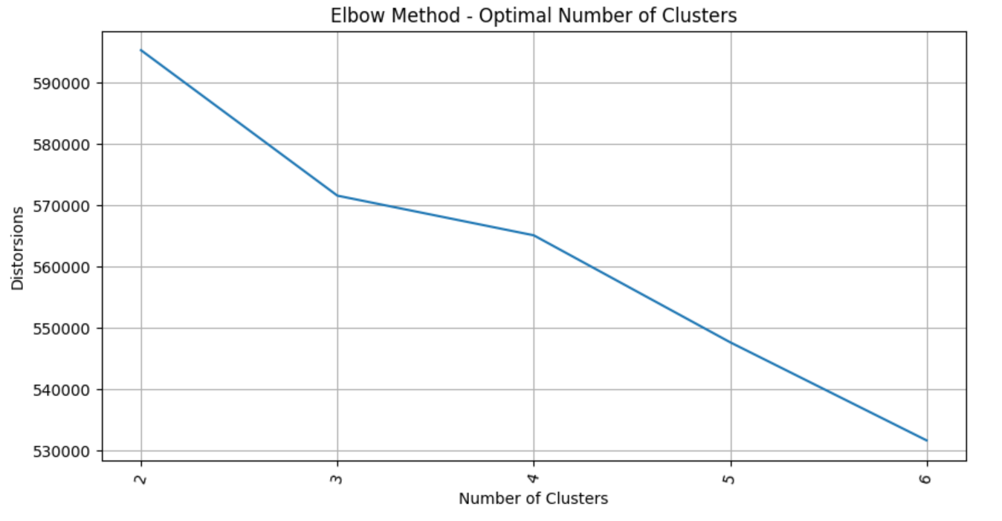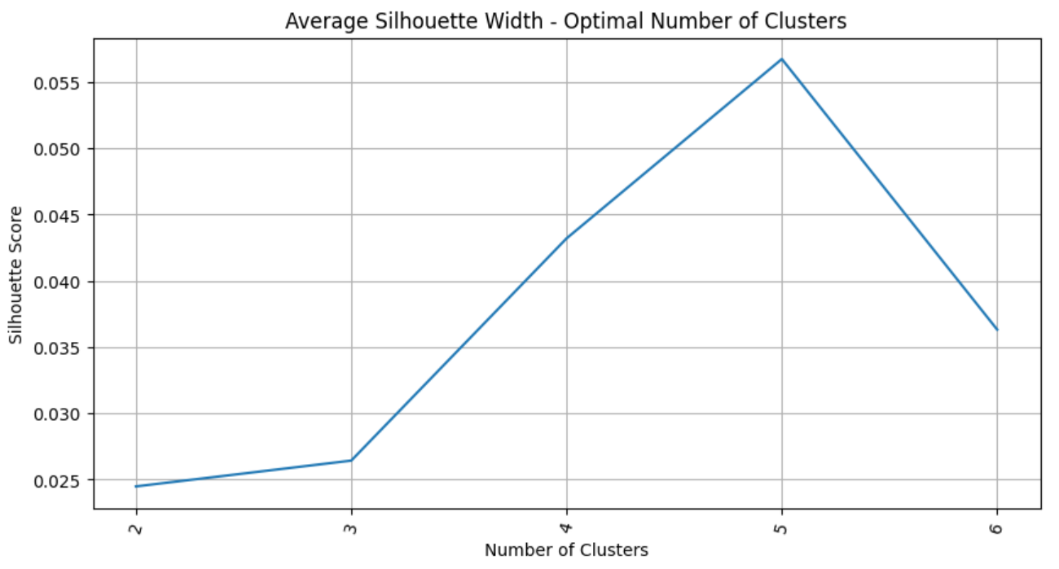The model can further be used for classifying new financial documents into labels returned by K-Means model.